Project 2

Title
War of Machines.
Simple game simulator.

Course
CSC-17A

Section
48969

Due Date
November 5, 2017

Author
Kremena Yanev

Table of Contents

1 Introduction 3
2 Game Play and Rules 3
3 Development Summary 4
3.1 Comments about developing the codes 4
4 Specifications 4
4.1 Sample Inputs/Outputs 5-9
4.2 Activity Diagrams 9
4.2.1 Battle Functions 9-10
4.3 Variables 11
4.4 Constant Fields 11-12
5 References 12-13
6 Program Listing 13-14
6.1 Main.cpp 14-23
6.2 Actor.h 23-24
6.3 BonusPt.cpp………………………………………..………………………………………..24-25
6.4 BonusPt.h………………………………………………..…………………………………..25-26
6.5 GameDate.h…………………………………………………..…………………………………26
6.51 GameDate.cpp……………………………………………………..……………………………27
6.6 Developer.cpp.…………………………………………………………..…………………..27-29
6.61 Developer.h….………………………………………………………………..…………………29
6.7 Creator.h…..……………………………………………………………………….……………30
6.71 Creator.cpp…..……………………………………………………………………….……. 30-31
7 Copy of Original Proposal 31-32

Introduction
After thinking a lot about what game I should create for this project, and having no idea, I imagined that my favorite movie is Transformers and it would make a great game. Creating a simple game simulator that can actually perform certain forms of battle is always thrilling for gamers.

By creating a game which will need the usage of only the keypad will be a fun and fast experience. It has every requirement that the Project needs to have and I think that even though it is a simple simulator it is actually fun to be played.

In the beginning of the Game you have two options. Option number one is to start a New Game or option number two to quit. If you chose option one, you have two options again. The first one is to start and save new character or to continue with load of previous selection. After passing by this menus, the fun begins and function battle is called to perform battle. There is a random generator to generate the difficulty of the enemy (medium, hard or insane mode) and after you know your enemy’s difficulty you need to use different tactics to achieve a victory. There are several options for attack, depends on the energy you and your enemy have. Both start from 0 energy and after every move you gain 1 energy. Upon the character selected you have the chance either to Heal, Block attack or gain Power.

The Game will end when one of the opponents hits 0 or negative health. It will display a message for winner or loser and statistics.

Game Play and Rules

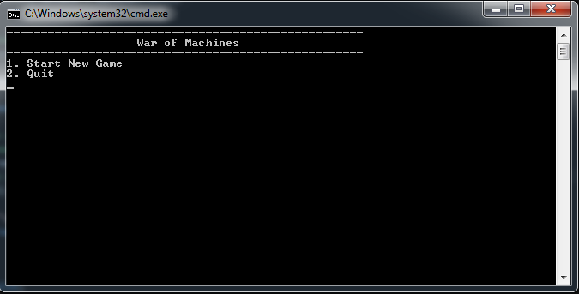
In the beginning of the Game you will see the display message which shows how the game is named and the options to continue.

It is a simple menu option – 1 for New Game or 2 for Exit.

If enter is 1, the player will see the other options that the Game provides – save, load, character selection, battle options, player’s turn and what types of attack he can use, statistics for game and ending message for winner or loser.

If enter is 2, the game will just be closed.

The following table indicates the differences between each difficulty level of enemy:
Features | Normal | Hard | Insane
Attack | 50 | 60 | 70
Health | 600 | 650 | 655
Moves | 1 | 1 | 1

Development Summary
Lines of Code | 840
Comment Lines | 199
Blank Lines (White space) | 93
Total Lines of Source File | 1132

For creating this project I have used C++ concepts we have learned in class and followed conventional rules to express my ideas. I have followed strictly the directions that were set up for creating this project and made sure every concept exist inside.

Comments about developing the codes
I have provided the user with enough comments about my coding and explain every step I have done. This will help the user to contemplate my intentions and my ideas faster and easier.

Specifications

Sample Inputs/Outputs
My whole Game is made by simple Inputs and Outputs. The only thing the user needs to use is the keypad and to read the screen. By reading the screen correctly the user will be able to play and if there is an incorrect enter, there is an Input Validation menu that will make sure the right key has been entered. I have provided you will series of screenshots:

Pictures that shows the screen when “Start New Game” Options is entered.

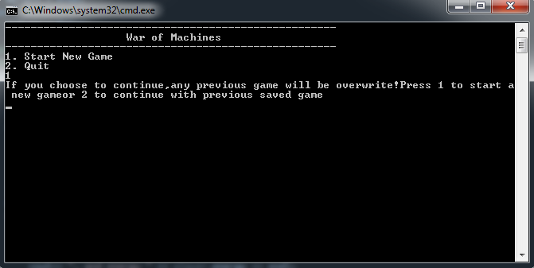

Menu that provides the user with two Options (1.To start a new game of 2. To load previous selection). In the picture below, the user entry was to start a New Game.

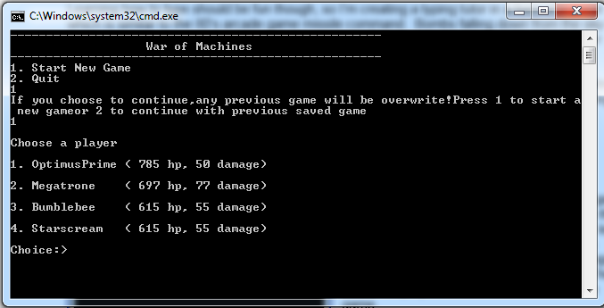

Pictures that shows the beginning of the battle between user and enemy. It also shows that user has been healed, which is a change 1 to 10. It shows the options the user has about attacking the enemy, based on the energy he has (starts from 0, +1 every move).

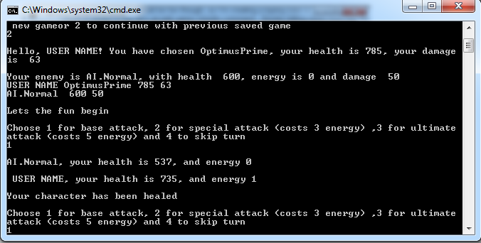

Ending battle message providing the winner’s name and both of user and enemy statistics.

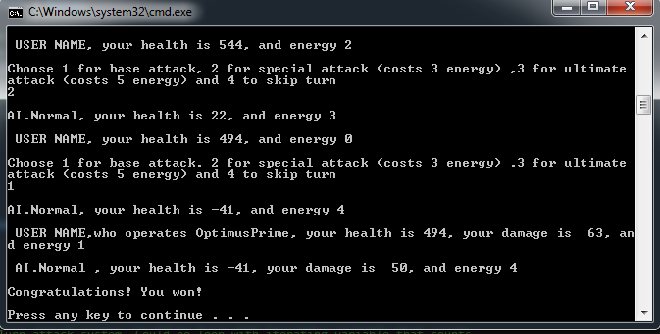

Screenshot that shows the menu for Input Validation in action.

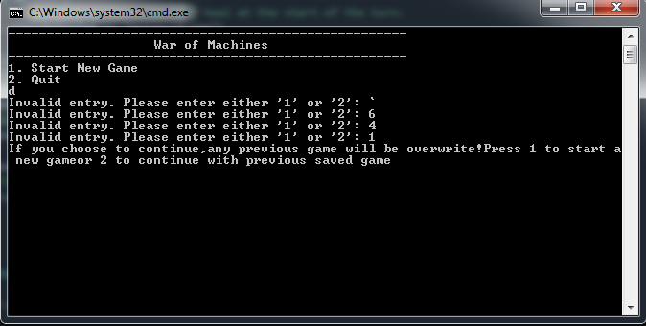

Bonus Level (using classes) is called with random chance, every time a player or the enemy hits. It can provide either one of the parties with certain amount of health. There is Option Mega Bonus, but it called only if the user guess the number from 1-100. Either way you will gain Bonus Health.

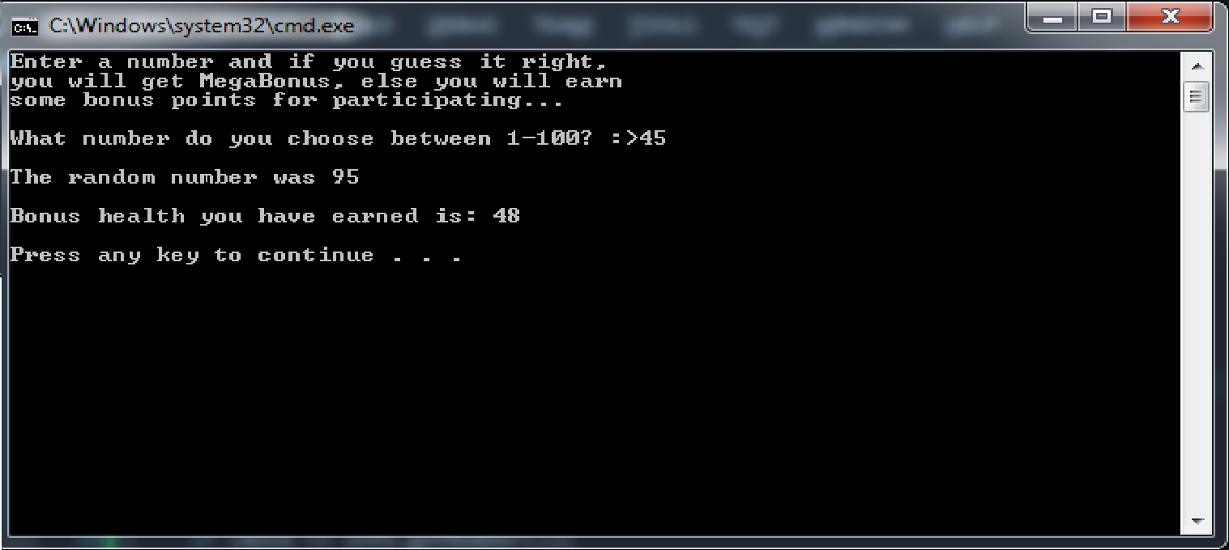

Bonus points for Enemy is determine by randomization. If the first number is equal to the second, the AI will get mega Bonus, otherwise Bonus will be determine by the second number.

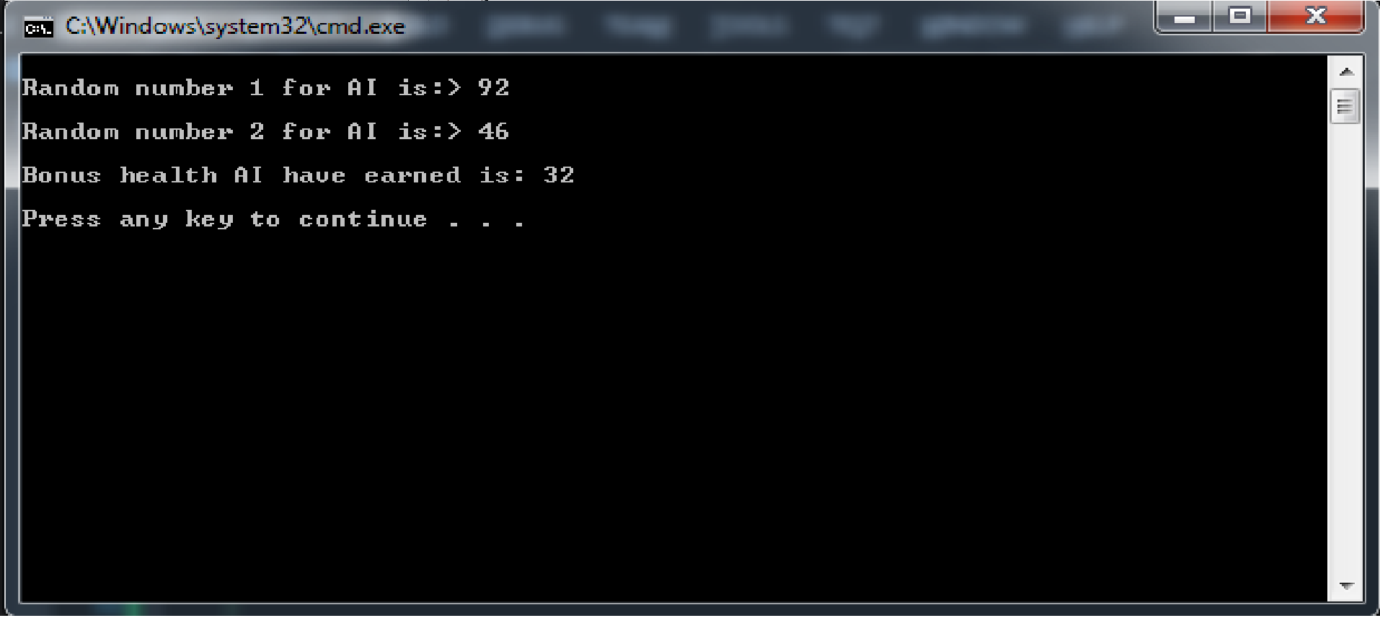

When game is started the user is asked to enter accurate date, which includes day, month year, so it will saved for user, when he is loading next time, it will show the last save and the date It was saved. The functions has the option to check if month is 28, 30 or 31 days and it will show that to user.
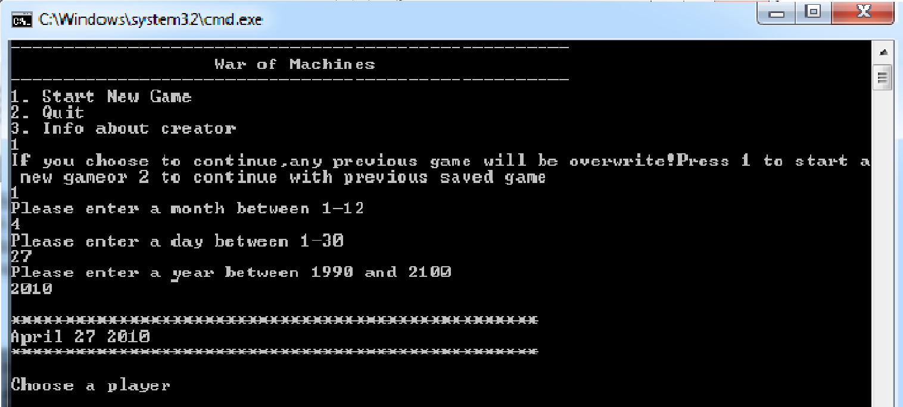

When you load the game it will load the previous save data but it will show it as m/d/y.

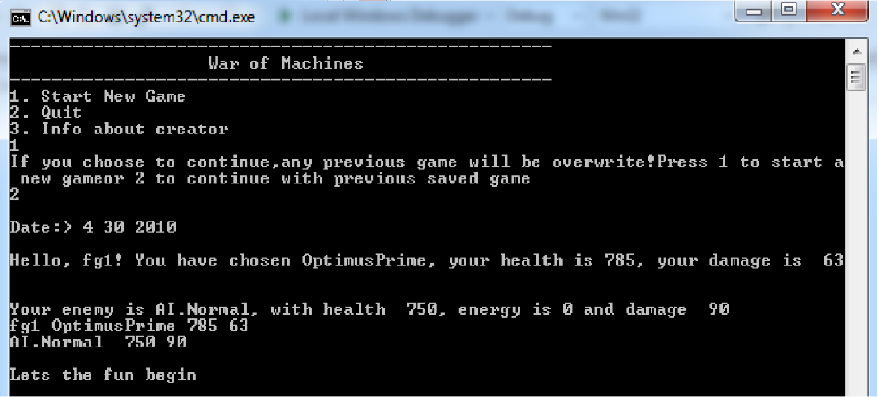

From chapter 15 I had use hierarchies and inheritance to inherit ate a certain class and later on display it in main using void function and actually you can change the data inside, but it is there as an example of things contemplate in class. If you press 3 in the main menu it will display developer and several random things.
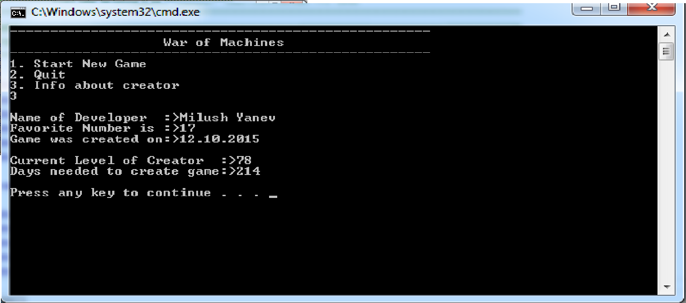

Activity Diagrams
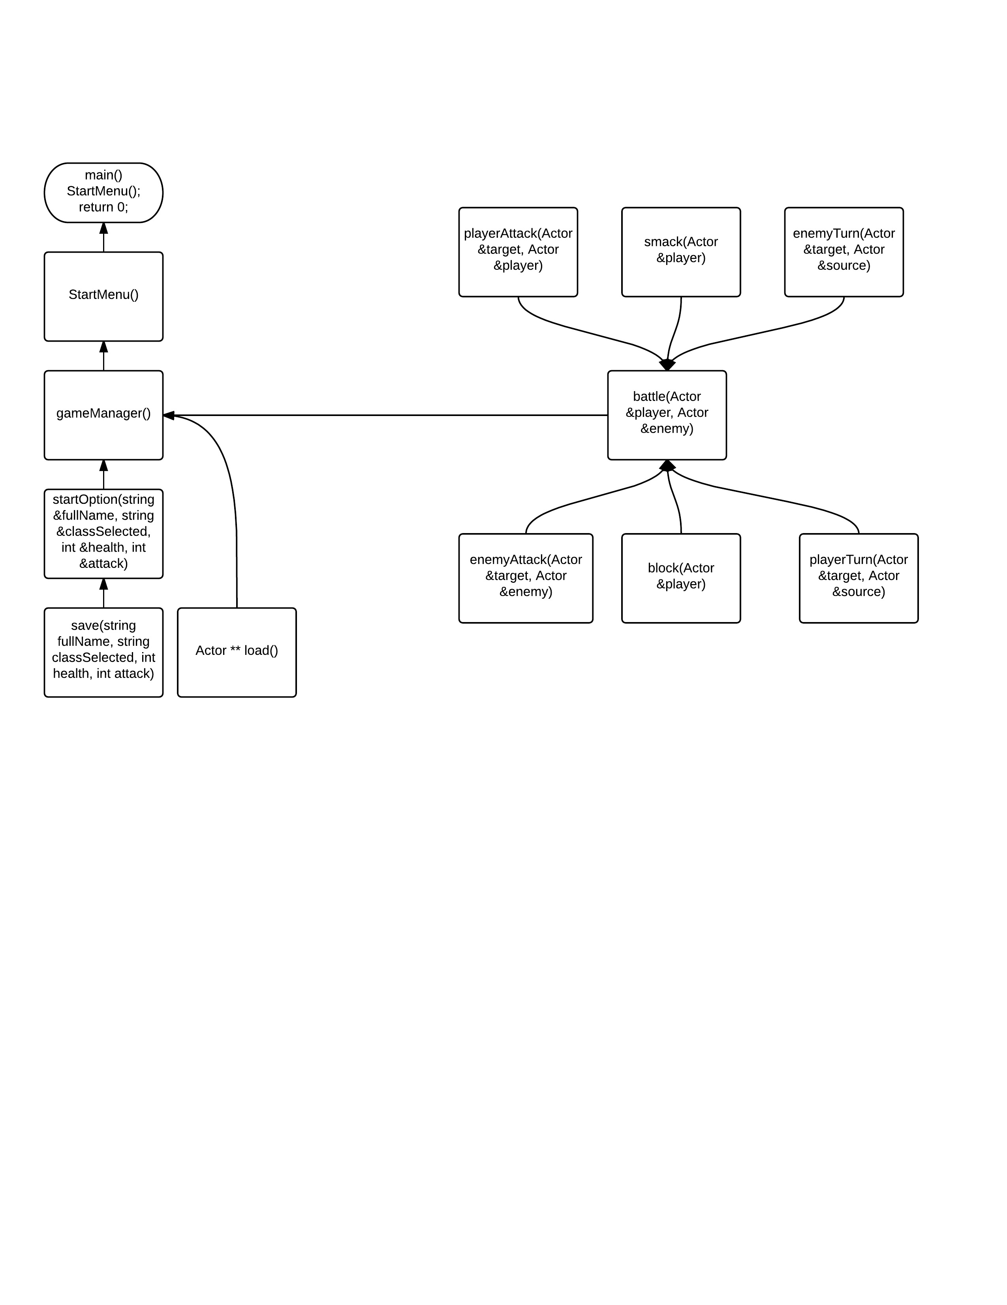

Every function leads to gameManager. From there it goes to StartMenu and StartMenu goes to main. The function of main is only to call StartMenu or exit game.

Battle Function
The Purpose of the Battle Function is to combine the data from six functions and execute them inside. It is the function with most importance in the Game because it will let know the developer whether or not the combination of the six functions is working the way it should. The main function of battle function is to actually perform the battle between the player and enemy and declare who is the winner, after performing series of actions which come from calling the other six functions. The function is called into gameManager and the outcome will go to StartMenu.

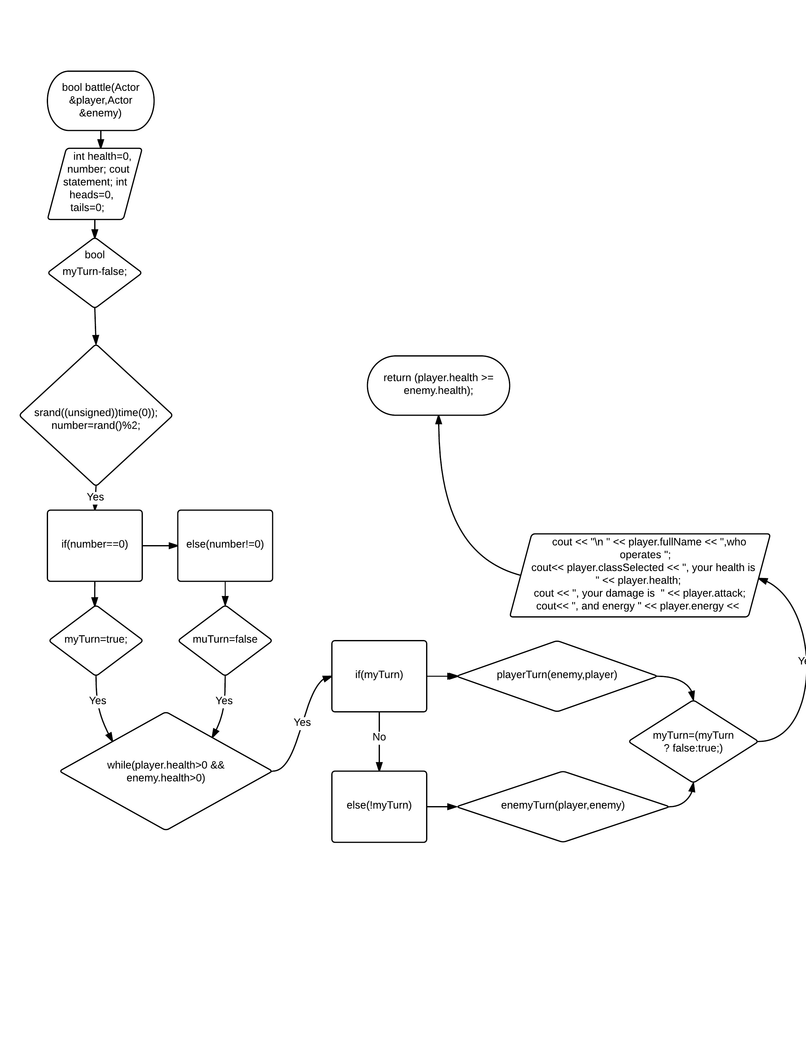

Variables
My main variables as well as function types are created in Actor.h. There are also local variables created in the sub menus, but only to determine certain move from keyboard(they don’t contain any important data).
#ifndef ACTOR_H
#define ACTOR_H

struct Actor
{
int attack;
int health;
string fullName;
string classSelected;
int energy;

};
Actor ** load();
void startMenu();
void gameManager();
void startOption(string &fullName, string &classSelected, int &health, int &attack);
void save(string fullName, string classSelected, int health, int attack);
void playerAttack(Actor &target, Actor &player);
void enemyAttack(Actor &player, Actor &enemy);
void heal(Actor &player);
void smack(Actor &player);
bool block(Actor &player);
bool battle(Actor &player, Actor &enemy);

#endif

Constant Fields
I made it easy to change some of the aspects of the game play and locations of the labels and components by declaring a list of constant fields. Here is a list, with comments of the fields defined in this section (the updates for version 2 are marked in blue):

//Define Character selections

classSelected = "OptimusPrime";
health = 785;
attack = 63;

classSelected = "Megatrone";
health = 697;
attack = 70;

classSelected = "Bumblebee";
health = 715;
attack = 57;

classSelected = "Starscream";
health = 705;
attack = 65;

//Defines Enemy statistics

enemy.fullName = "AI.Hard";
enemy.attack = 60;
enemy.health = 650;
enemy.energy = 0;

enemy.fullName = "AI.Normal";
enemy.attack = 50;
enemy.health = 600;
enemy.energy = 0;

enemy.fullName = "AI.Insane";
enemy.attack = 70;
enemy.health = 655;
enemy.energy = 0;

Concepts Used
Chapter 9 Concepts
- Arrays
- References
- Passing Arrays to Methods
- Dynamic Memory Allocation
- Relationship between Arrays and Pointers
- Initializing Pointers
- Using Smart Pointers to Avoid Memory Leaks

Chapter 10 Concepts
- C-strings
- Library Functions for Working with C-strings
- Character Testing
- Character Case Conversion
Chapter 11 Concepts
- Initializing a Structure
- Accessing Structure Members
- Array of Structures
- Return a Structure from a Function
- Pointers to Structures
Chapter 12 Concepts
- Passing File Stream Objects to Functions
- Binary Files
- Open a File for Both Input and Output
Chapter 13 Concepts
- Introduction to Classes.
- Constructors and passing arguments to Constructors.
- Destructors.
- Private and Public Member functions and declarations.
Chapter 14 Concepts
- Instance and static members
- Copy Constructors.
- Copy Constructors Destructors.
- Object conversion.
- Aggregation
Chapter 15 Concepts
- Inheritance
- Redefining Base Class functions
- Polymorphism and Virtual Member Functions
- Multiple Inheritance

5 References

Google Initiated Sites

Most of the references I have used for creating this projects were from google sites. Unfortunately I didn’t keep track of all the sites I was using because their number were significant. I was using how to apply different concepts and found similar answers to my questions. No code was copied from the sites.

Program Listing

Main.cpp
/******************************************************************************/
/**********************Project number two.Continue PJ one **********************
********************************************************************************
00000000011111111112222222222333333333344444444445555555555666666666677777777778
12345678901234567890123456789012345678901234567890123456789012345678901234567890
/******************************************************************************/

#include <iostream>
#include <cstdlib>
#include <fstream>
#include <ctime>
#include<string>
#include <Windows.h>

using namespace std;

#include "Actor.h"
#include "BonusPt.h"
#include "GameDate.h"
#include "Developer.h"
#include "Creator.h"

int main()
{

//Function startMenu will exist only in main().
startMenu();

return 0;
}
void startMenu()
{
cout << "----------------------------------------------------" << endl;
cout << " War of Machines " << endl;
cout << "----------------------------------------------------" << endl;

cout << "1. Start New Game " << endl;
cout << "2. Quit" << endl;
cout << "3. Info about creator" << endl;

//call gameManager() function.
gameManager();

}
void gameManager()
{
//Initialize variables and character.
Actor **result;
string classSelected = " ",
fullName = " ";
int health=0,
attack=0;
char n,
j;

cin >> n;
//While loop to make sure that entered choice is correct.
while (n != '1' && n != '2' && n !='3')
{
cout << "Invalid entry. Please enter either '1' or '2': ";
cin >> n;
}
if (n == '1')
{
cout << "If you choose to continue,";
cout << "any previous game will be overwrite!";
cout << "Press 1 to start a new game";
cout << "or 2 to continue with previous saved game" << endl;
cin >> j;
//While loop to make sure that entered choice is correct.
while (j != '1' && j != '2' )
{
cout << "Invalid entry. Please enter either '1' or '2': ";
cin >> j;
}
if (j == '1')
{
//Call startOption menu to pick up character.
startOption(fullName, classSelected, health, attack);

}
if (j == '1' || j == '2') {

//Load function if player choose to continue with saved game.
Actor *player = new Actor;
Actor *enemy = new Actor;
GameDate *date = new GameDate;

//load
load(*date,*player, *enemy);

//print message
cout << player->fullName << " " << player->classSelected << " ";
cout<< player->health << " " << player->attack << endl;
cout << enemy->fullName << " " << enemy->classSelected << " ";
cout<< enemy->health << " " << enemy->attack << endl;

// true = win
if (battle(*player, *enemy))
// Print an ending message indicating winner.
cout << "\nCongratulations! You won!\n" << endl;
else
//Print an ending message indicating loser.
cout << "\nSorry! Try again!\n" << endl;

return;
}
} else if (n == '2') {
//Print an ending message.
cout << "\nGood Bye!\n" << endl;
}
else if (n == '3'){

CRTR();
}
}
//Function startOption to determine character choice
void startOption(string &fullName, string &classSelected, int &health, int &attack)
{
GameDate *date = new GameDate;
GameDate::MDY(date);

cout << "\nChoose a player" << endl;
cout << "\n1. OptimusPrime ( 785 hp, 50 damage)" << endl;
cout << "\n2. Megatrone ( 697 hp, 77 damage)" << endl;
cout << "\n3. Bumblebee ( 615 hp, 55 damage)" << endl;
cout << "\n4. Starscream ( 615 hp, 55 damage)" << endl;
cout << "\nChoice:> ";
//Create integer to stand for character selection.
char m;
cin >> m;
//While loop to make sure that entered choice is correct.
while (m != '1' && m != '2' && m != '3' && m != '4')
{
cout << "Invalid entry. Please enter either '1' or '2' or '3' or '4': ";
cin >> m;
}

if (m == '1')
{
//Character 1.
cout << "\nCongratulations You Have Chosen OptimusPrime" << endl;
classSelected = "OptimusPrime";
health = 785;
attack = 3;

}
else if (m == '2')
{
//Character 2.
cout << "\nCongratulations You Have Chosen Megatrone" << endl;
classSelected = "Megatrone";
health = 697;
attack = 70;
}
else if (m == '3')
{
//Character 3.
cout << "\nCongratulations You Have Chosen Bumblebee" << endl;
classSelected = "Bumblebee";
health = 715;
attack = 57;
}
else if (m == '4')
{
//Character 4.
cout << "\nCongratulations You Have Chosen Starscream" << endl;
classSelected = "Starscream";
health = 705;
attack = 65;
}
cout << "\nWhat is your name? " << endl;
//Ignore previous Entries.
cin.ignore();

//Enter the name you have chosen.
cout << "\nName: "; getline(cin, fullName);
//Print your name,hero with its stats.
cout << "\nWelcome to War Of Machines, " << fullName << " ,you have chosen ";
cout << classSelected << " with " << health << endl;
cout<< " hp and damage " << attack;
cout<< "!\n" << endl;
//Call save function to save previous entries.
save(*date,fullName, classSelected, health, attack);
}
//Function save to save entries in the beginning of the game.
void save(GameDate &date,string fullName, string classSelected, int health, int attack)
{
char choice;
//Write file.
ofstream writeFile;
cout << "Saving now will overwrite any previously saved data\n";
cout<< "Do you want to save Y or N" << endl;
cin >> choice;
if (choice = 'Y' || 'y')
{
//Write file in playerInfo.bin, which will occur in folder of game.
//Use binary save file.
writeFile.open("playerInfo.bin", ofstream::binary);

//write month from getMonth
int month = date.getMonth();
writeFile.write((char *)& month, sizeof(int));

//write day from getDay
int day = date.getDay();
writeFile.write((char *)& day, sizeof(int));

//write year from getYear
int year = date.getYear();
writeFile.write((char *)& year, sizeof(int));

//Declare the length using characters,which reffer to strings.
int length = fullName.length();

//Find how many characters are in string (+1).
writeFile.write((char *)&length, sizeof(int));

//Write size of characters.
writeFile.write(fullName.c_str(), length);

length = classSelected.length();
//Find how many characters are in string (+1).
writeFile.write((char *)&length, sizeof(int));

//Write size of characters.
writeFile.write(classSelected.c_str(), length);

//Write health and attack as character pointers, using size.
writeFile.write((char *) & health, sizeof(health));
writeFile.write((char *) & attack, sizeof(attack));

//writeFile << fullName << classSelected << health << attack;
cout << "The game has been saved\n";
//Close writen file.
writeFile.close();

}
else
{
//If enter is N, skip writing, end function.
exit(0);
}

}
//Function load to load previous save or external file.
//Pass Struct as an array of pointers.
void load(GameDate &date,Actor &player, Actor &enemy)
{
ifstream readFile;
int health;
int attack;
//Read playerInfo.bin from saved function.
//You can also add you personal file to be read.
readFile.open("playerInfo.bin", ifstream::binary);

//read month from binary file
int month = 0;
readFile.read((char*)&month, sizeof(int));

//read day from binary file
int day = 0;
readFile.read((char*)&day, sizeof(int));

//read year from binary file
int year = 0;
readFile.read((char*)&year, sizeof(int));

//declare date type
date.setMonth(month);
date.setDay(day);
date.setYear(year);

int length = 0;
readFile.read((char *) &length, sizeof(int));

//Create an array buffer as pointer. Must be +1,
//Because it will count char(last char is 0).
char *buffer = new char[length + 1];
//for loop to make sure count will be length +1.
for (int i = 0; i < length + 1; i++)
{
buffer[i] = 0;
}
readFile.read(buffer, length);
string fullName(buffer);
//release allocated memory
delete [] buffer;

readFile.read((char *)&length, sizeof(int));

buffer = new char[length + 1];
//for loop to make sure count will be length +1.
for (int i = 0; i < length + 1; i++)
{
buffer[i] = 0;
}
readFile.read(buffer, length);
string classSelected(buffer);
//release allocated memory.
delete[] buffer;

readFile.read((char *)& health, sizeof(int));
readFile.read((char *)& attack, sizeof(int));

player.fullName = fullName;
player.classSelected = classSelected;
player.health = health;
player.attack = attack;
player.energy = 0;

//Print message.
cout << "\nDate:> " << date.getMonth() << " " << date.getDay() << " " << date.getYear()<<endl;
cout << "\nHello, " << player.fullName;
cout<< "! You have chosen " << player.classSelected;
cout << ", your health is " << player.health;
cout<< ", your damage is " << player.attack << endl;

//Enemy is automatically set up.
int move = ((unsigned)time(0) % 100) + 1;
if (move <= 35)
{
enemy.fullName = "AI.Hard";
enemy.attack = 100;
enemy.health = 800;
enemy.energy = 0;
}
else if (move > 35 && move <= 85)
{
enemy.fullName = "AI.Normal";
enemy.attack = 90;
enemy.health = 750;
enemy.energy = 0;
}
else if (move > 85 && move <= 100)
{
enemy.fullName = "AI.Insane";
enemy.attack = 95;
enemy.health = 800;
enemy.energy = 0;
}

cout << "\nYour enemy is " << enemy.fullName;
cout<< ", with health " << enemy.health;
cout << ", energy is " << enemy.energy << " and damage ";
cout<< enemy.attack << endl;
//Close file and continue.
readFile.close();
}
//Player attack.
void CRTR()
{
//inheritance of Developer in Creator
Creator dayLevl;

//class Developer
dayLevl.setName("Milush Yanev");
dayLevl.setNumber(17);
dayLevl.setDate("12.10.2015");

//call result from get function
cout << "\nName of Developer :>" << dayLevl.getName() << endl;
cout << "Favorite Number is :>" << dayLevl.getNumber() << endl;
cout << "Game was created on:>" << dayLevl.getDate() << endl;

//class Creator
dayLevl.setLevel(78);
dayLevl.setDay(214);

//call result from get function
cout << "\nCurrent Level of Creator :>" << dayLevl.getLevel() << endl;
cout << "Days needed to create game:>" << dayLevl.getDay() << "\n" << endl;
}
void playerAttack(Actor &target, Actor &player)
{
char choice = '0';
int ultimateAttack;
int move;

cout<< "\nChoose 1 for base attack, 2 for special attack (costs 3 energy)";
cout<<" ,3 for ultimate attack (costs 5 energy) and 4 to skip turn" << endl;
//Use attack based from choice and do damage to target's health value.
cin >> choice;
//While loop to make sure that entered choice is correct.
while (choice != '1' && choice != '2' && choice != '3' && choice != '4')
{
cout << "Invalid entry. Please enter either '1' or '2' or '3' or '4': ";
cin >> choice;
}

if (choice == '1')
{
//1 = base attack - base attack value.
target.health -= player.attack;
}
else if (choice == '2' && player.energy >= 3)
{
//2 = special attack - costs 3 energy and will modify,
//without storing the damage output i.e finalDmg = baseAttack + special.
target.health -= (player.attack + 100);
//Deduct energy amount per turn.
player.energy -= 3;
}
else if (choice == '3' && player.energy == 5)
{
//3 = ultimate - Same method of modofying as above.
//Gamble with 5 energy if this will do damage between 1-8 damage.
//Use rand() for this with a min and max range.
srand((unsigned)time(0));
move = (rand() % 8) + 1;

if (move >= 2 && move <= 4)
{
ultimateAttack = 130;
}

else if (move == 8)
{
ultimateAttack = 150;

}
else
{
ultimateAttack = 100;
}
//Deal damage to target based from player's attack value.
target.health -= (player.attack + ultimateAttack);
//If successful check, deduct matching energy amount.
player.energy -= 5;
}
//4 = end turn - hey, maybe you're out of energy.
else if (choice == '4')
{
return;

}
}
//Function for enemy attack moves.
void enemyAttack(Actor &target, Actor &enemy)
{ //Make the game interesting. Allow the enemy to randomly modify his damage.
//Output each attack by allowing baseAttack + random range from 1-5.
int RandomAttack = 0;
int move = ((unsigned)time(0) % 5) + 1;

if (move == 1)
{
RandomAttack = 0;

}
else if (move > 1 && move <= 3 && enemy.energy >= 2)
{
RandomAttack = 70;
//Deduct energy amount per turn.
enemy.energy -= 2;
}
else if (move == 4 && enemy.energy == 5)
{
RandomAttack = 90;
//Deduct energy amount per turn.
enemy.energy -= 5;
}
else if (move == 5)
{
target.health = target.health;
}
//Deal damage to target based from enemy's attack value.
target.health -= (enemy.attack + RandomAttack);
}
//Function to block enemy's attack.
bool block(Actor &player)
{
if (player.classSelected == "Megatrone" || player.classSelected == "Starscream")
{
srand((unsigned)time(0));
Sleep(100);
//Return true or false based from a random chance between 1 - 10 odds.
//You will need to choose one number as a constant in that range.
int move = (rand() % 10) + 1;
//Compare the random number to that number.
if (move == 5)
{
cout << "\nBlocked" << endl;
return true;
}
else
{
return false;
}
}
}
void heal(Actor &player)
{ //If mage, he can have a chance to self heal at the start of the turn.
if (player.classSelected == "OptimusPrime")
{
srand((unsigned)time(0));
//The chance will be a random chance between 1 - 10 odds you will need
//to choose, one number as a constant in that range.
int move = (rand() % 10) + 1;
//Compare the random number to that number.
if (move == 4)
{
cout << "\nYour character has been healed" << endl;
//Choose an amount to heal your player and add that to his health.
player.health += 79;
}

}
}
void smack(Actor &player)
{
if (player.classSelected == "Bumblebee")
{
srand((unsigned)time(0));
//The chance will be a random chance between 1 - 10 odds you will need
//to choose, one number as a constant in that range.
int move = (rand() % 10) + 1;
//Compare the random number to that number.
if (move == 6 || move ==1)
{
cout << "\nYour character has gained power" << endl;
//Choose an amount to heal your player and add that to his health.
player.attack += 15;
player.energy += 3;
}
}
}
//Function to determine Computer's turn.
void enemyTurn(Actor &target, Actor &source)
{
srand((unsigned)time(0));
//number must be from 1-10
int tt = (rand() % 10) + 1;
//if move=6 call bonus
if (tt == 6)
{
source.health += Bonus::AI_Bns();
}

//Add 1 energy per turn.
source.energy++;
if (source.energy < 0)
{
source.energy = 0;
}

// Randomly select an enemy action based on simple AI logic.
//Randomize choice and use basic logic to make the game interesting.

//If the function blocks, no need to use enemyAttack.
if (!block(target)) // if not blocked
{
// Call attack function based on AI choice.
enemyAttack(target, source);
}
// - attack(actor &, actor, char ).
}
void playerTurn(Actor &target, Actor &source)
{
srand((unsigned)time(0));

//number must be from 1-10
int tt = (rand() % 10) + 1;
//if move=4 call bonus
if (tt == 4)
{
source.health += Bonus::BonH();
}

//energy++
source.energy++;
if (source.energy > 5)
{
source.energy = 5;
}

//If mage - chance to heal() at this start of turn if damaged.
heal(source);

//if bumblebee selected you can gain extra power
smack(source);

//If the function blocks, no need to use playerAttack.
if (!block(target)) // if not blocked
{
// Call attack function based on AI choice.
playerAttack(target, source);
}

//Grab input from player on attack choice from a menu of choices.
//Call attack function based on player choice between 1-4.
//Energy check, if invalid choice loop for another choice.
playerAttack(target, source);

// For example: attack() and pass as reference enemy as target,
//and player as player as a read only argument.
}
//Function for battle, if true==win.
bool battle(Actor &player, Actor &enemy)
{
int health = 0;
int number;
bool myTurn = false;
//Battle starting text.
cout << "\nLets the fun begin " << endl;
//Coin toss to see who goes first.
int heads = 0, tails = 0;
//Use srand ((unsigned) time(0)); Requires <ctime>.
srand((unsigned)time(0));
//Use coinToss = rand() % 2.
number = rand() % 2;
//Heads (0) you, tails (1) enemy.
if (number == 0)
myTurn = true;
else
myTurn = false;

//While loop that checks the enemy and player's health.
//While it is greater than 0, keep playing. Both live.
while (player.health > 0 && enemy.health > 0)
{
//If else loop to determine player/computer(i.e.) moves.
if (myTurn)
{
playerTurn(enemy, player);
cout << "\n" << enemy.fullName << ", your health is ";
cout<< enemy.health;
cout<< ", and energy " << enemy.energy << endl;
}
else
{
enemyTurn(player, enemy);
cout << "\n " << player.fullName << ", your health is ";
cout<< player.health;
cout<< ", and energy " << player.energy << endl;
}
//Turn attack system. Could be loop with iterating variable that counts
//from 0-1,and then resets after one.Just make sure each player gets a
//sequential turn.Alternate turn; if it was my turn, then it's his next.
myTurn = (myTurn ? false : true);

//Keep a running tally of the player and enemy's stats (i.e health& energy).
}
cout << "\n " << player.fullName << ",who operates ";
cout<< player.classSelected << ", your health is " << player.health;
cout << ", your damage is " << player.attack;
cout<< ", and energy " << player.energy << endl;
cout << "\n " << enemy.fullName << " " << ", your health is ";
cout<< enemy.health << ", your damage is ";
cout<< enemy.attack << ", and energy " << enemy.energy << endl;
// Print an ending message indicating winner.
return (player.health >= enemy.health);
}

Actor.h
#ifndef ACTOR_H
#define ACTOR_H

struct Actor
{
int attack;
int health;
string fullName;
string classSelected;
int energy;

};
Actor ** load();
void startMenu();
void gameManager();
void startOption(string &fullName, string &classSelected, int &health, int &attack);
void save(string fullName, string classSelected, int health, int attack);
void playerAttack(Actor &target, Actor &player);
void enemyAttack(Actor &player, Actor &enemy);
void heal(Actor &player);
void smack(Actor &player);
bool block(Actor &player);
bool battle(Actor &player, Actor &enemy);

#endif

BonusPt.cpp

#include<iostream>
#include <ctime>
#include<cstdlib>
#include "BonusPt.h"

using namespace std;

//overloading constructor
Bonus::Bonus()
{
number = 0;
chance = 8;
mBonus = 15;

}
//call destructor
Bonus::~Bonus()
{

}
int Bonus::BonH(){

int BonScore;
Bonus info;
//need a menu to validate choice is in the right range
cout << "Enter a number and if you guess it right, ";
cout << "you will get MegaBonus, else you will earn ";
cout << "some bonus points for participating..." << endl;
cout << "\nWhat number do you choose between 1-100? :>";
//call function to declare a variable
info.setNumber();
//randomization to check with number entered
srand((unsigned)time(0));

//number must be from 0-100
int move = (rand() % 100) + 1;

//show number
cout << "\nThe random number was " << move << endl;
// call function with number selected,
//if == to choice, call big bonus points
if (move == info.getNumber()){

BonScore = info.getMBonus();
cout << "AMAZING!!! You have earned Mega Bonus" << endl;
cout << "\nBonus health you have earned is: " << BonScore << endl;

}
//else if statement to determine the amount of bonus
else if (move > 20 && move<50){
BonScore = info.getBonus() * 4;
cout << "\nBonus health you have earned is: " << BonScore << "\n" << endl;
}
else if (move>50 && move < 80){
BonScore = info.getBonus() * 5;
cout << "\nBonus health you have earned is: " << BonScore << "\n" << endl;
}
else if (move>80 && move < 100){
BonScore = info.getBonus() * 6;
cout << "\nBonus health you have earned is: " << BonScore << "\n" << endl;
}

else if (move>0 && move < 20){
BonScore = info.getBonus() * 7;
cout << "\nBonus health you have earned is: " << BonScore << "\n" << endl;
}
//return BonScore
return BonScore;
}
int Bonus::AI_Bns()
{
int BonScore;
Bonus info;

//declare two variables, to compare later on
int move1, move;
//call randomization to generate number
srand((unsigned)time(0));
{
//find out first random variable
move1 = (rand() % 100) + 1;
cout << "\nRandom number 1 for AI is:> " << move1 << endl;
}
//find out second value, to determine bonus points
move = (rand() % 100) + 1;
cout << "\nRandom number 2 for AI is:> " << move << endl;

//if num1=num2 give MegaBonus
if (move1 == move){

//score is called from getMBonus()
BonScore = info.getMBonus();
cout << "AMAZING!!! AI have earned Mega Bonus" << endl;
cout << "\nBonus health AI have earned is: " << BonScore << endl;
}
//else determine Bonus score upon num2
else if (move > 20 && move<50){
BonScore = info.getBonus() * 4;
cout << "\nBonus health AI have earned is: " << BonScore << "\n" << endl;
}
else if (move>50 && move < 80){
BonScore = info.getBonus() * 5;
cout << "\nBonus health AI have earned is: " << BonScore << "\n" << endl;
}
else if (move>80 && move < 100){
BonScore = info.getBonus() * 6;
cout << "\nBonus health AI have earned is: " << BonScore << "\n" << endl;
}

else if (move>0 && move < 20){
BonScore = info.getBonus() * 7;
cout << "\nBonus health AI have earned is: " << BonScore << "\n" << endl;
}
//return BonScore
return BonScore;

}

6.4 BonusPt.h
#ifndef BONUSPT_H
#define BONUSPT_H

#include<iostream>
using namespace std;

//declare class
class Bonus{

private:
int number, chance, mBonus;
public:
//constructor
Bonus();

//desctructor
~Bonus();

//static member, chapter 14.1
static int BonH();
static int AI_Bns();
void setNumber() { cin >> number; };
int getNumber()const{ return number; };
int getBonus()const{ return chance; };
int getMBonus() const{ return chance*mBonus; };

};

#endif

6.5 GameDate.h
#ifndef GameDate_H
#define GameDate_H

class GameDate
{
private:

//initialize variables
//*day as pointer to create copy constructor
int day,
month,
year;

public:

//constructor
GameDate();

//copy constructor
GameDate(const GameDate &obj);

//desctructor
~GameDate();

//create class functions
void setMonth(int);
void setDay(int);
void setYear(int);

//using static members as void
static void MDY(GameDate *);

//functuions to get data and print
int getDay();
int getMonth();
int getYear();
void print();

}; #endif

6.51 GameDate.cpp
#include <iostream>
#include <string>

//call GameDate header file
#include "GameDate.h"

using namespace std;

//constructor
GameDate::GameDate()
{
this->day = 0;
this->month = 0;
this->year = 0;
}
//copy constructor
GameDate::GameDate(const GameDate &obj)
{
this->day = obj.day;
this->month = obj.month;
this->year = obj.year;
}
//destructor
GameDate::~GameDate()
{

}
//set Day
void GameDate::setDay(int d)
{
this->day = d;
}
//set Month
void GameDate::setMonth(int m)
{
this->month = m;

}
//set Year
void GameDate::setYear(int y)
{
this->year = y;
}
//get the Date
int GameDate::getDay()
{
return day;
}
//get Month
int GameDate::getMonth()
{
return month;
}
//get Year
int GameDate::getYear()
{
return year;
}
//initilize the array and fill it
void GameDate::print()
{
//create constant array that hold number of monhts
static const int MonthDays[] = { 0, 1, 2, 3, 4, 5, 6, 7, 8, 9, 10, 11, 12 };
//create string array that holds name of months
static const string MonthName[] = { "", "January", "February", "March", "April",
"May", "June", "July", "August", "September", "October", "November", "December" };

//printing message month,day,year
cout << "\n*************************************************" << endl;
cout << MonthName[month] << " " << day << " " << year << endl;
cout << "*************************************************" << endl;
}

void GameDate::MDY(GameDate *date)
{

//initialize variables
int day = 0;
int month = 0;
int year = 0;

//enter a valid month
cout << "Please enter a month between 1-12" << endl;
cin >> month;

//while loop to check input
while (month < 1 || month>12)
{
cout << "Please enter a valid month" << endl;
cin >> month;
}
//if statement to determine days of certain month
if (month == 1 || month == 3 || month == 5 || month == 7
|| month == 8 || month == 10 || month == 12)
{
//enter valid days
cout << "Please enter a day between 1-31" << endl;
cin >> day;
//while loop to check if corrected day was entered
while (day < 1 || day >31)
{
cout << "Please enter a valid positive number between 1 and 31" << endl;
cin >> day;
}
}
else if (month == 4 || month == 6 || month == 9 || month == 11)
{
//enter valid days
cout << "Please enter a day between 1-30" << endl;
cin >> day;

//while loop to check if corrected day was entered
while (day < 1 || day >30)
{
cout << "Please enter a valid positive number between 1 and 30" << endl;
cin >> day;
}
}
else if (month == 2)
{
//enter valid days
cout << "Please enter a day between 1-28" << endl;
cin >> day;

//while loop to check if corrected day was entered
while (day < 1 || day >28)
{
cout << "Please enter a valid positive number between 1 and 28" << endl;
cin >> day;
}
}
//enter year from certain range
cout << "Please enter a year between 1990 and 2100" << endl;
cin >> year;

//while loop to determine range
while (year < 1990 || year>2100)
{
cout << "Please enter a year between 1990 and 2100" << endl;
cin >> year;
}
//set day, month,year
date->setDay(day);
date->setMonth(month);
date->setYear(year);

//print out date
date->print();
}

6.6 Developer.cpp
#include "Developer.h"

//set default class
Developer::Developer()
{
name = "John Smith";
number = 000;
date = "1/1/2000";
}
Developer::Developer(string n, int num, string d)
{
name = n;
number = num;
date = d;
}
Developer::Developer(const Developer& orig)
{

}
//alocate
Developer::~Developer()
{

}
//call functios for certain class
void Developer::setName(string n)
{
name = n;
}
void Developer::setNumber(int num)
{
number = num;
}
void Developer::setDate(string d)
{
date = d;
}
//get result
string Developer::getName()
{
return name;
}
int Developer::getNumber()
{
return number;
}
string Developer::getDate()
{
return date;
}

6.61 Developer.h

#ifndef DEVELOPER_H
#define DEVELOPER_H
#include <string>

using namespace std;

class Developer{
protected:
string name;
string date;
int number;

public:
Developer();
Developer(string, int, string);
Developer(const Developer& orig);
~Developer();
void setName(string);
void setNumber(int);
void setDate(string);
string getName();
int getNumber();
string getDate();

};
#endif

6.7 Creator.h
#ifndef CREATOR_H
#define CREATOR_H
#include <string>
#include "Developer.h"
using namespace std;

class Creator :public Developer

{
private:
int day;
int level;
public:
Creator();
~Creator();
void setDay(int);
void setLevel(int);
int getDay();
int getLevel();

};
#endif

6.71 Creator.cpp
#include <iostream>
#include<string>
#include "Creator.h"
using namespace std;

Creator::Creator()
{
day = 0;
level = 0;
}
Creator::~Creator()
{

}
void Creator::setDay(int d)
{
day = d;
}
void Creator::setLevel(int l)
{
level = l;
}
int Creator::getDay()
{
return day;
}
int Creator::getLevel()
{
return level;
}

Copy of Original Proposal

Create a Game that will have the following:

Memory allocation and de-allocation.
Functions with structures, used as input and output
Pointers with arrays and arrays of structures, internally as well as externally.
Use of character arrays as well as string objects.
Reading and writing to binary files.
Introduction to Classes.
Constructors and passing arguments to Constructors.
Destructors.
Private and Public Member functions and declarations.
Instance and Static Members.
Copy constructor and object conversion.
Aggregation.
Polymorphism and Virtual Member functions.
Class Hierarchies and Multiple Inheritance.
Basically anything in Chapters 9 to 16 from Gaddis.
Also, use doxygen to document your code in addition to flowcharting.

Concepts I’ll have to learn:
- Binary file conversion
- Passing Struct as a Pointer
- The need of using classes to be an efficient code
- Better understanding class hierarchies
- Better understanding multiple Inheritance

